**Task on jenkins-03**

1) Create one jenkins job using the below code and create three stages.

stage1: Git clone to download the source code.

stage2: Sonarqube Integration to check the quality of code

stage3: Slack Integration to send the alerts to slack.

URL: <https://github.com/betawins/VProfile-1.git>

**stage1: Git clone to download the source code.**

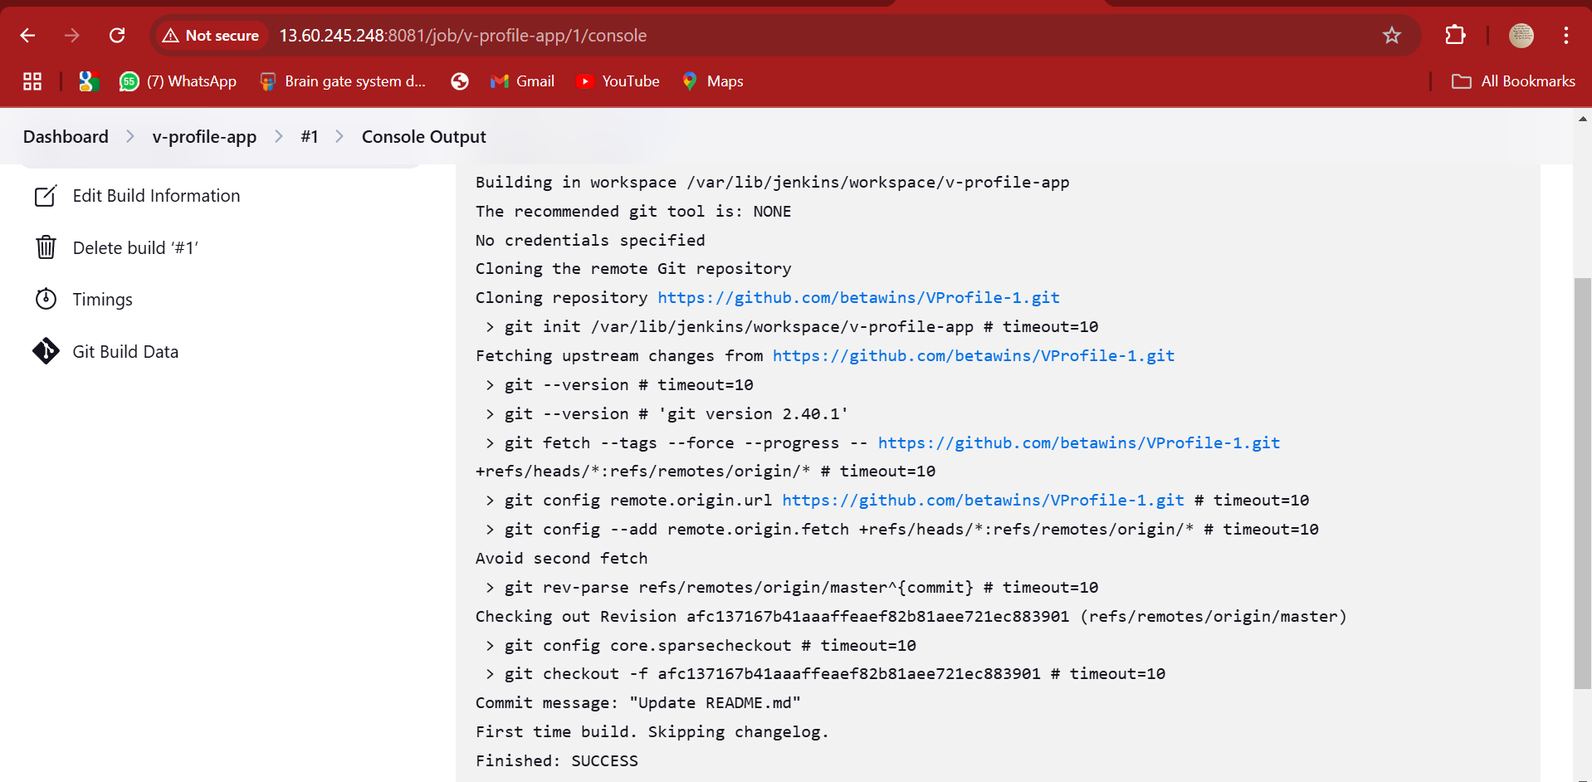

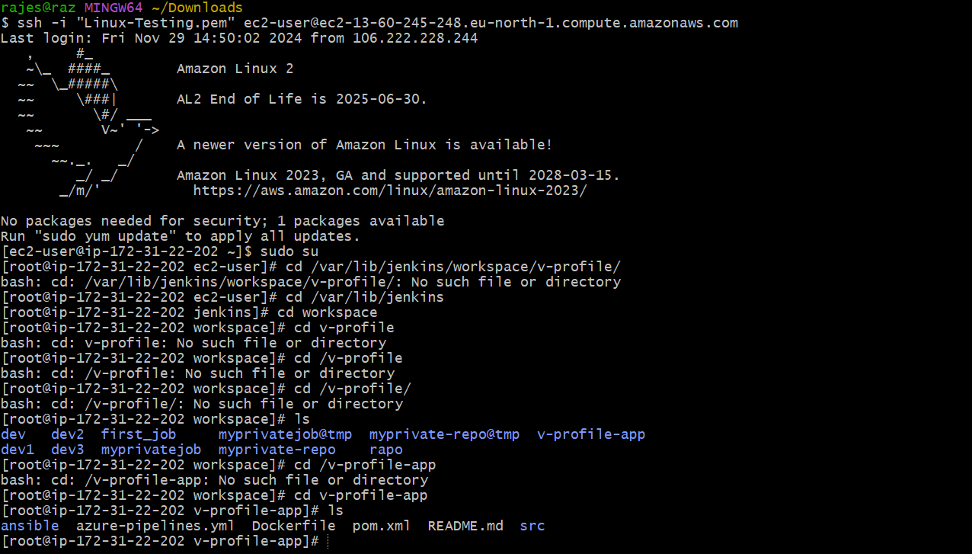

**stage2: Sonarqube Integration to check the quality of code**

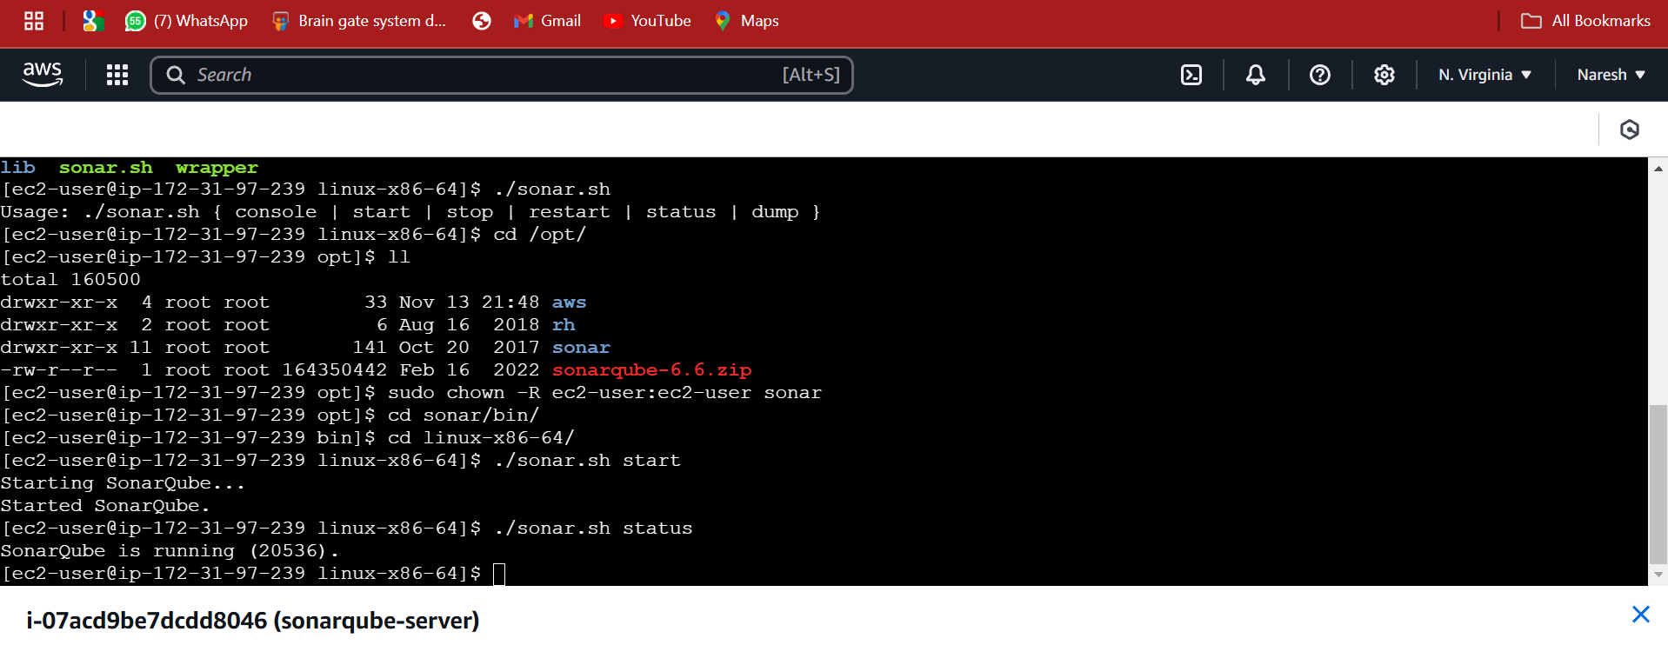

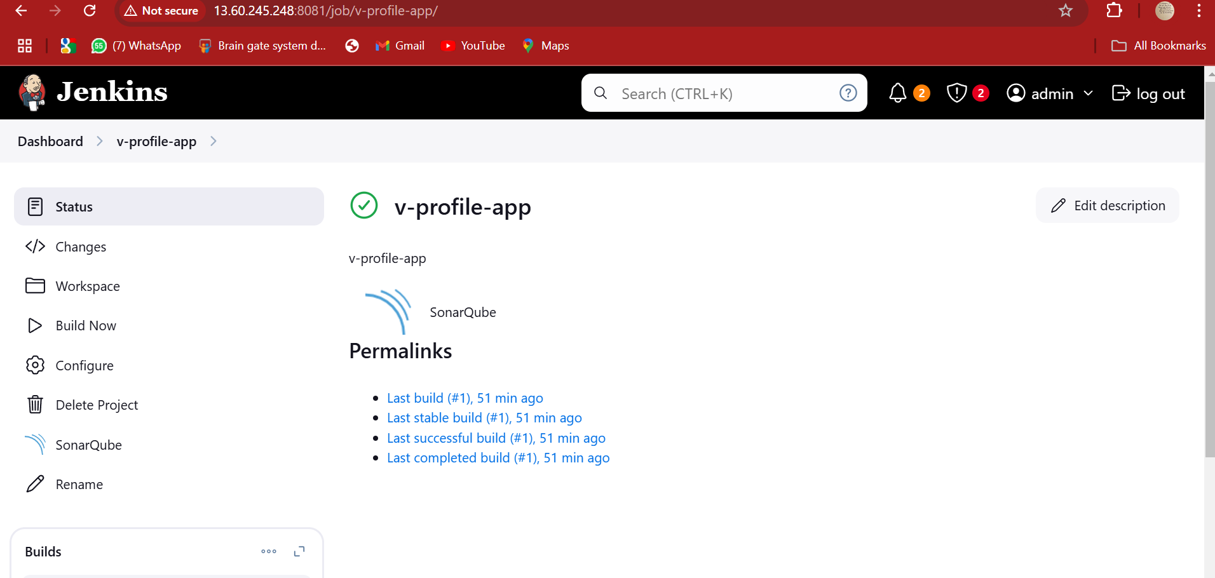

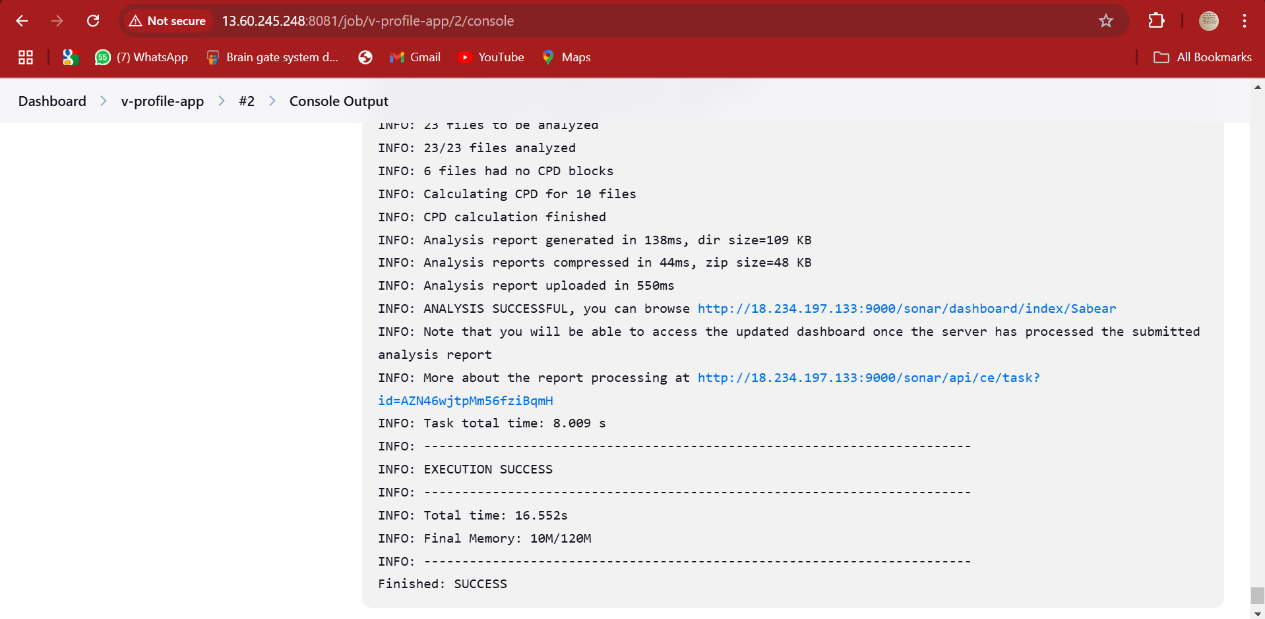

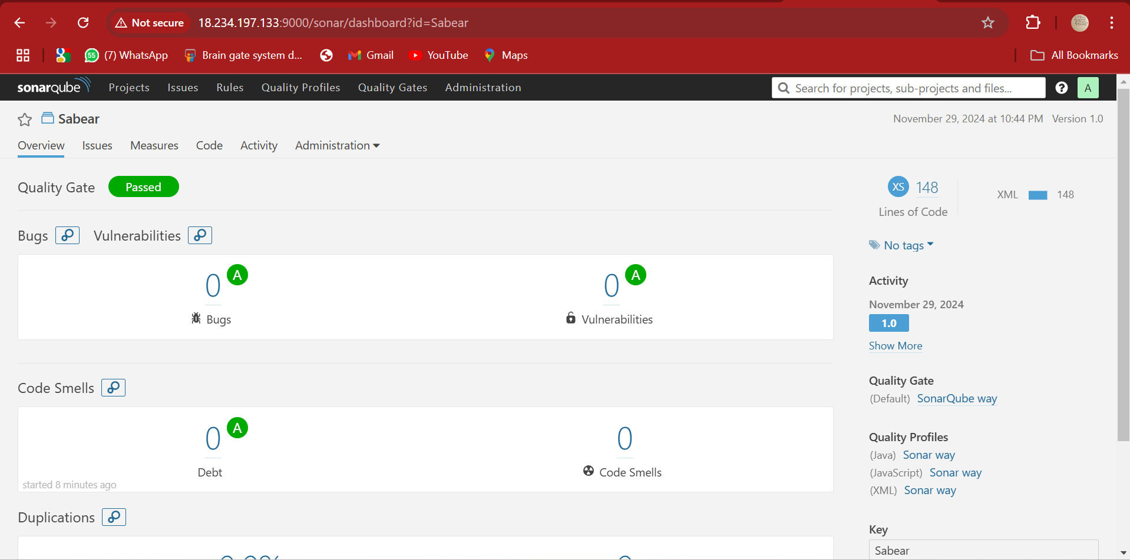

**stage3: Slack Integration to send the alerts to slack**

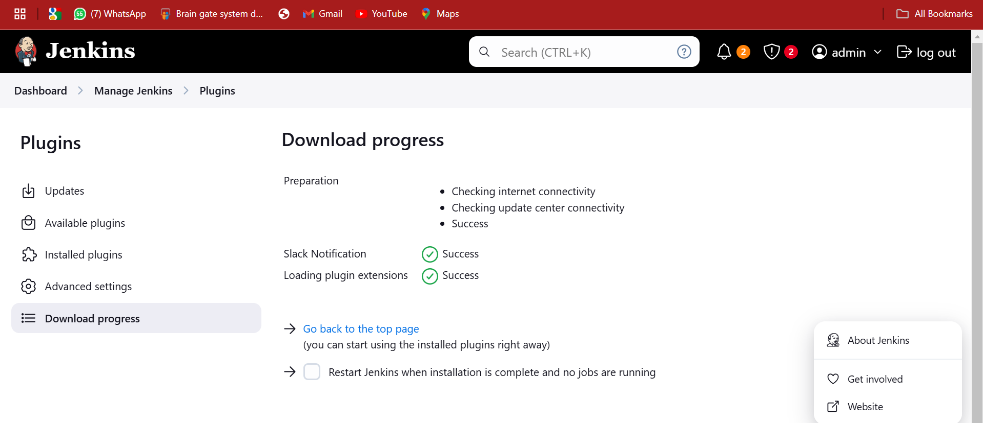

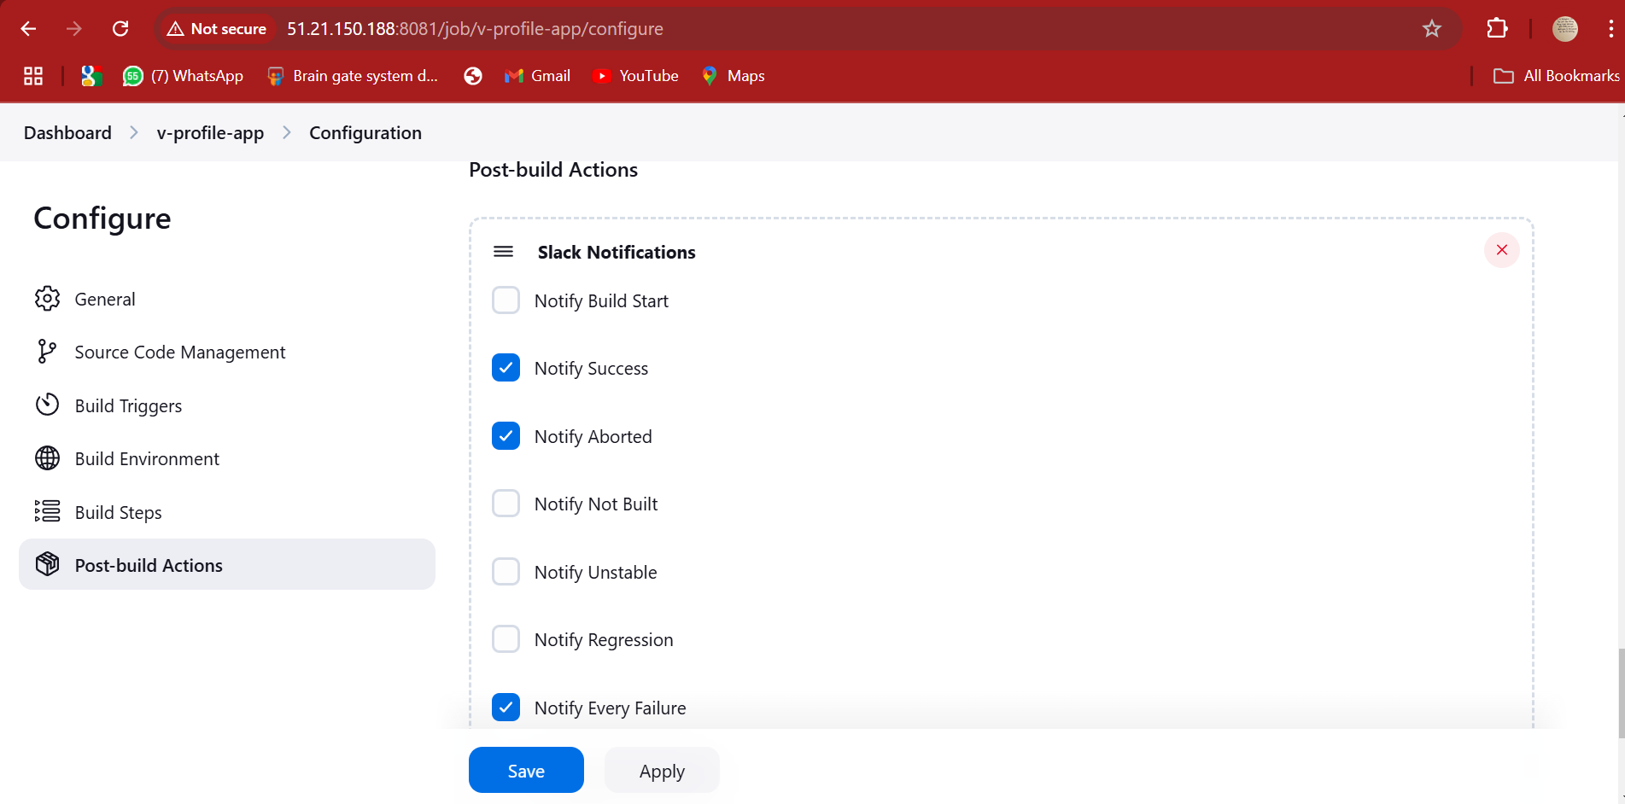

2) 1) Create one jenkins job using the below code and create three stages.

stage1: Git clone to download the source code.

stage2: Sonarqube Integration to check the quality of code

stage3: Slack Integration to send the alerts to slack.

URL: <https://github.com/betawins/hiring-app.git>